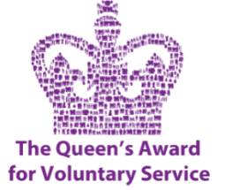
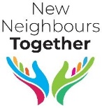
Advice and Admin Support

Job Purpose
New Neighbours together is a client focused charity providing a warm, hospitable welcome for all sanctuary seekers in Burnley. Our advice and admin team play a crucial role in enabling and empowering people to successfully navigate the road to rebuilding their lives here in Burnley.
Reporting to A&A lead practitioner and General Manager
Time commitment: Able to work flexibly Monday, Tuesday, Thursday between 9.30 and 2:30pm according to service needs.
Working with individual clients
- Listening carefully and identifying problems and concerns people need help with.
- Completing paperwork and official forms for clients.
- Liaising with outside agencies on behalf of the client both orally and in writing ( after training).
- Maintaining thorough individual IT based client records including using Advice Pro ( training will be available)
- Ensuring all policies and procedures are followed and consulting A&A manager in any necessary issues.
Administration
- Assisting in maintaining comprehensive client records, the production of reports, data analysis etc
- Answering outside email and phone enquiries referring to management as appropriate.
- Immediately passing on any unresolved problems which people raise during sessions to A&A manager
- Other administrative tasks as required
- Maintaining office filing and organisation
- Maintaining a tidy and welcoming office environment
- Adhering to our lone office working policy at all times
Training
- General and specific role induction prior to first working day
- Working together with the Manager or experienced Advice volunteer in first weeks
- Ongoing ‘on the job’ training on specific subjects involved in Advice work
- Other more specialised training as required
Person Description
- ‘People’ person – good listener, friendly style and excellent communicator
- Problem solving / can do approach
- Excellent organisational and time- management skills and attention to detail
- Ability to work well under pressure and cope with a demanding case load.
- Adaptable and ready to learn
- Good IT skills with knowledge of Microsoft Office and other commonly used IT packages
- Team player – enjoy working as part of a larger team
- Inclusive style – respectful of diversity and religious/cultural beliefs
- Other languages, knowledge of other religions and cultures an asset.

